Subwatersheds
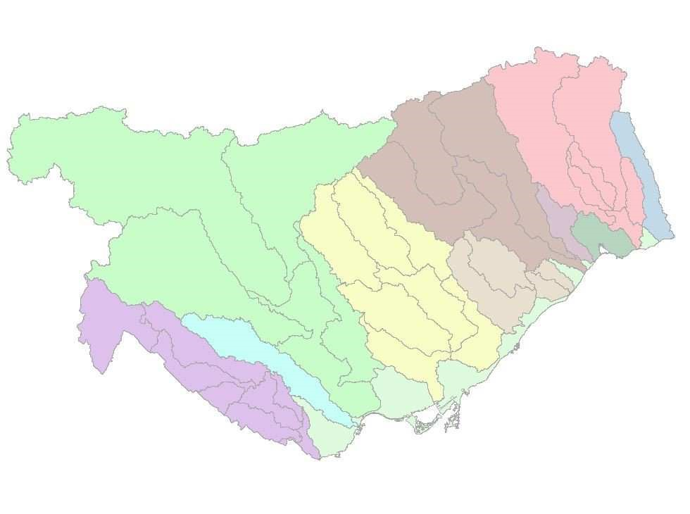
File Geodatabase Feature Class
Tags
subwatersheds, watersheds
Summary
shows the subwatersheds of the 9 watersheds in TRCA's jurisdiction Description
sub watershed boundaries in TRCA jurisdiction. These subwatersheds are a compilation of sub watershed boundaries delineated through the use of a DEM (2002) and ArcHydro. This was originally created to replace the older sub watershed boundaries that contained overlaps and gaps.
Because these sub watershed were derived from a different source and methodology that the TRCA_Jurisdiction boundary there will be differences between the overall jurisdiction, and watershed boundaries.
Credits
TRCA
Use limitations
There are no access and use limitations for this item.
Extent
West -80.030415 East -78.970267
North 44.058594 South 43.575845
Scale Range
Maximum (zoomed in) 1:5,000
Minimum (zoomed out) 1:150,000,000

ArcGIS Metadata ►

Topics and Keywords ►
THEMES OR CATEGORIES OF THE RESOURCE environment, boundaries
*CONTENT TYPE Downloadable Data
EXPORT TO FGDC CSDGM XML FORMAT AS RESOURCE DESCRIPTION No

Citation ►
*TITLE Subwatersheds
CREATION DATE 2000-01-01 00:00:00
PRESENTATION FORMATS *digital map
OTHER CITATION DETAILS
Unknow source and date of when this dataset was created

Citation Contacts ►
RESPONSIBLE PARTY
INDIVIDUAL'S NAME TRCA
ORGANIZATION'S NAME TRCA
CONTACT'S POSITION GIS CONTACT'S ROLE owner
CONTACT INFORMATION ►
PHONE
VOICE 416 661-6600
ADDRESS
TYPE
DELIVERY POINT 5 Shoreham Drive CITY Toronto
ADMINISTRATIVE AREA Ontario
POSTAL CODE M3N 1S4
COUNTRY CA
HOURS OF SERVICE
8:30-4:30

Resource Details ►
DATASET LANGUAGES *English (UNITED STATES)
SPATIAL REPRESENTATION TYPE *vector
*PROCESSING ENVIRONMENT Version 6.2 (Build 9200) ; Esri ArcGIS 10.4.1.5686
CREDITS
TRCA
ARCGIS ITEM PROPERTIES
*NAME Subwatersheds
*LOCATION file://\\arcgis02\GIS\DataGDB\Basemap\basemap.gdb
*ACCESS PROTOCOL Local Area Network

Extents ►
EXTENT
GEOGRAPHIC EXTENT
BOUNDING RECTANGLE
EXTENT TYPE Extent used for searching
*WEST LONGITUDE -80.030415
*EAST LONGITUDE -78.970267
*NORTH LATITUDE 44.058594
*SOUTH LATITUDE 43.575845
*EXTENT CONTAINS THE RESOURCE Yes
EXTENT IN THE ITEM'S COORDINATE SYSTEM
*WEST LONGITUDE 578269.827600
*EAST LONGITUDE 662610.885400
*SOUTH LATITUDE 4826735.000000
*NORTH LATITUDE 4878845.000000
*EXTENT CONTAINS THE RESOURCE Yes

Spatial Reference ►
ARCGIS COORDINATE SYSTEM
*TYPE Projected
*GEOGRAPHIC COORDINATE REFERENCE GCS_North_American_1983
*PROJECTION NAD_1983_UTM_Zone_17N
*COORDINATE REFERENCE DETAILS
PROJECTED COORDINATE SYSTEM
WELL-KNOWN IDENTIFIER 26917
- ORIGIN -5120900
- ORIGIN -9998100
XY SCALE 10000
- ORIGIN -100000
Z SCALE 10000
M ORIGIN -100000
M SCALE 10000
XY TOLERANCE 0.001
Z TOLERANCE 0.001
M TOLERANCE 0.001
HIGH PRECISION true
LATEST WELL-KNOWN IDENTIFIER 26917
WELL-KNOWN TEXT PROJCS["NAD_1983_UTM_Zone_17N",GEOGCS
["GCS_North_American_1983",DATUM["D_North_American_1983",SPHEROID
["GRS_1980",6378137.0,298.257222101]],PRIMEM["Greenwich",0.0],UNIT
["Degree",0.0174532925199433]],PROJECTION["Transverse_Mercator"],PARAMETER
["False_Easting",500000.0],PARAMETER["False_Northing",0.0],PARAMETER
["Central_Meridian",-81.0],PARAMETER["Scale_Factor",0.9996],PARAMETER
["Latitude_Of_Origin",0.0],UNIT["Meter",1.0],AUTHORITY["EPSG",26917]]
REFERENCE SYSTEM IDENTIFIER
*VALUE 26917
*CODESPACE EPSG
*VERSION 6.13(3.0.1)

Spatial Data Properties ►
VECTOR ►
*LEVEL OF TOPOLOGY FOR THIS DATASET geometry only
GEOMETRIC OBJECTS
FEATURE CLASS NAME Subwatersheds
*OBJECT TYPE composite
*OBJECT COUNT 39
ARCGIS FEATURE CLASS PROPERTIES ►
FEATURE CLASS NAME Subwatersheds
*FEATURE TYPE Simple
*GEOMETRY TYPE Polygon
*HAS TOPOLOGY FALSE
*FEATURE COUNT 39
*SPATIAL INDEX TRUE
*LINEAR REFERENCING FALSE

Distribution ►
DISTRIBUTION FORMAT
*NAME File Geodatabase Feature Class VERSION 10.3

Fields ►
DETAILS FOR OBJECT Subwatersheds ►
*TYPE Feature Class
*ROW COUNT 39
DEFINITION
Subwatershed Names
DEFINITION SOURCE
TRCA Watershed Reports
FIELD Shape ►
*ALIAS Shape
*DATA TYPE Geometry
*WIDTH 0
*PRECISION 0 *SCALE 0
*FIELD DESCRIPTION Feature geometry.
*DESCRIPTION SOURCE
Esri
*DESCRIPTION OF VALUES Coordinates defining the features.
FIELD WSHED ►
*ALIAS WSHED
*DATA TYPE String
*WIDTH 16
*PRECISION 0
*SCALE 0
FIELD DESCRIPTION
Watershed Names
DESCRIPTION SOURCE unknown
DESCRIPTION OF VALUES
NA
FIELD Subshed ►
ALIAS Subwatersheds
*DATA TYPE String
*WIDTH 50
*PRECISION 0
*SCALE 0
FIELD DESCRIPTION
Subwatershed Names - Names were collected from the various watershed reports.
DESCRIPTION SOURCE
TRCA
DESCRIPTION OF VALUES
NA

Metadata Details ►
*METADATA LANGUAGE English (UNITED STATES)
METADATA CHARACTER SET utf8 - 8 bit UCS Transfer Format
SCOPE OF THE DATA DESCRIBED BY THE METADATA *dataset
SCOPE NAME *dataset
*LAST UPDATE 2017-11-06
ARCGIS METADATA PROPERTIES
METADATA FORMAT ArcGIS 1.0
STANDARD OR PROFILE USED TO EDIT METADATA ISO19139
CREATED IN ARCGIS FOR THE ITEM 2014-12-01 10:35:49
LAST MODIFIED IN ARCGIS FOR THE ITEM 2017-11-06 15:48:39
AUTOMATIC UPDATES
HAVE BEEN PERFORMED Yes
LAST UPDATE 2017-11-06 15:38:49

Metadata Contacts ►
METADATA CONTACT
INDIVIDUAL'S NAME Jason Tam
ORGANIZATION'S NAME Toronto and Region Conservation
CONTACT'S POSITION GIS Analyst
CONTACT'S ROLE user

Metadata Maintenance ►
MAINTENANCE
UPDATE FREQUENCY not planned

